The Day They Parachuted Cats On Borneo
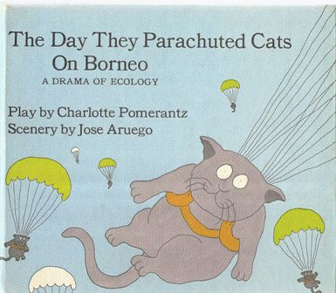
Yup. Cats raining down on the jungle. Dropped from airplanes. Not in individual kitty parachutes with goggles and flight jackets, but dropped from the sky nonetheless.
This story, as dramatized in the fascinating children’s book, “The Day They Parachuted Cats in Borneo“, is that DDT was sprayed by the World Health Organization to kill off malaria-carrying mosquitos but also affected the caterpillars in people’s roofs which lead to them eating the straw roofs up, leading to many collapsing houses, and then the lizards started eating the caterpillars, which slowed the lizards down enough so that cats could catch them and eat them, poisoning the cats. With the cats out of the picture, the rats took over and no one prefers a rat infestation to mosquitos. So new cats were brought in from Australia.
Amazing. For want of a nail… You change one thing… One tiny thing and then, rats.
Apparently this incident was described in The New York Times, November 13, 1969. “DDT Exemplifies Peril in Technological Gains; Cornell Ecologist Describes How the Cost of Progress Is Sometimes Too High”. But I don’t know for sure because I am not going to pay to access the article and google can’t find it replicated online.
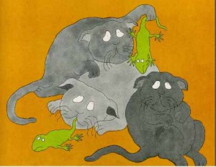
And there’s an odd radical children’s book all about it! People dropped Australian cats on Borneo.
In a 1994 article in the NY Times, the story was also related as part of “Books of The Times; Take Woe and Blend It with Humor” by Janet Maslin, in which she relates the narrator of Without a Hero Stories By T. Coraghessan Boyle Viking, describing how “and by the time we dropped the cats, well, the people were pretty hungry, and I supposed it was inevitable that we lost a good proportion of them right then and there.”

Systems Thinking Research
พฤษภาคม 13, 2015 BY PIMPLOYMIRA
Background information
Back in the fifties, people in a region of Borneo were having trouble with malaria. In an effort to save lives, the World Health Organization decided to sprayed the insecticide DDT all over the area, killing many mosquitoes and significantly reducing the incidence of malaria.
However, the World Health Organization failed to appreciate the full scope of their actions. DDT not only successfully killed mosquitoes – it also attacked a parasitic wasp population. These wasps, it turned out, had kept in check a population of thatch-eating caterpillars. So with the accidental removal of the wasps, the caterpillars flourished, and soon building roofs started falling in all over the place.
As if that was not enough the insects, poisoned by DDT, were consumed by geckoes. The biological half-life of DDT is around 8-years, so animals like geckoes do not metabolize it very fast, and it stays in their system for a long time. Those geckoes, carrying the DDT poison, were in turn hunted and eaten by the cat population. With far less cats, rats took over and multiplied, and this in turn led to outbreaks of typhus and sylvatic plague.
By now the cure had become worse than the initial disease, so the World Health Organization did what any self-respecting world health organization would do: they parachuted a bunch of live cats into Borneo. The event was known as Operation Cat Drop.
How is systems thinking essential and important in researches and decision-making processes?
The results of their actions demonstrate the importance of whole-systems thinking. If you don’t understand the inter-relatedness of things, solutions often cause more problems. Every problem always require complex and reflective thinking. So system thinking can help you to organize your thoughts and plan how to deal with problems.
Visual supports (can be a link to the video or pictures of actual event)
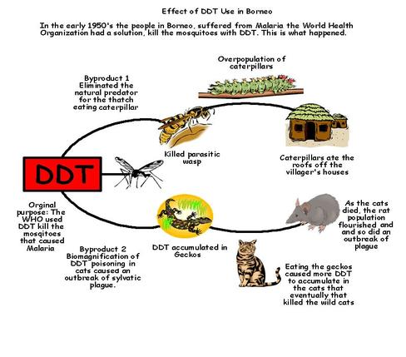
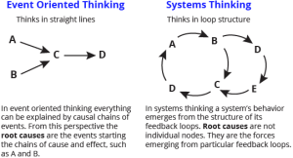
Citations
“Strange Loops – Systems Thinking: Operation Cat Drop and Chaotic Kindness.” Strange Loops – Systems Thinking: Operation Cat Drop and Chaotic Kindness. N.p., n.d. Web. 13 May 2015.

